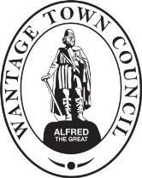

Wantage Town Council. Portway, Wantage, OX12 9BX

DONATION REQUEST FORM - GREAT BIG GREEN WEEK (6-14 JUNE 2026)
Name of Organisation:
Address of organisation:
Name of contact person and position within the organisation:
Email address:
What is the purpose and main activity of your Great Big Green Week event?
(Please explain how it will promote climate action)

Please give details of what you require funding for with a breakdown of costs.
(In some cases we may not be able to match the amount in full. Please provide a breakdown of individual items where possible.)
Total amount requested (up to £250) £

Please explain how the local community would benefit from your event:

Approximately how many people will you reach?
Please give the date and location that your event will take place (must be between 6 and 14 June):
Is your organisation a registered charity? ☐ Yes ☐ No If yes, please give the charity number:
Signed: Date:
Please submit the request to deputyclerk@wantagetowncouncil.gov.uk by 27 Feb 2026

